**Final Project Web Development and Coding Capstone: “Tommy’s Trains”**

Welcome to my capstone final project submission. I have chosen to do my site from scratch.

**Quick Backgrounder:**

I am looking at buying a local model train hobby shop in my area. The shop has a web site but, though it has lots of info on it, it is hard to navigate, has no mobile capability and plain looks crappy. One of my first acts as new owner (if I can buy it) would be to update the web site.

Also, I want to expand the site to incorporate e-commerce, likely with a platform like Shopify.

My wish to take this course was mainly to learn the principals of good web design so I can modify the existing shop web site.

I chose to do this project from scratch because there is so much wrong with the current site it would take too long to update for this course. And the coding on the Shopify platform is far too complex.

The site developed for this capstone project is a mock-up of a hobby shop site applying some of the principals we learned in this program.

**Quick Overview of “Tommy’s Trains”**

The site is 3 pages: “Home”, “Products” and “About Us”.

Navigation is by way of 3 buttons laid out horizontally near the top. “Activate” is used to indicate the page the user is on by reducing the opacity of the buttons (learned in the course).

“Home” page

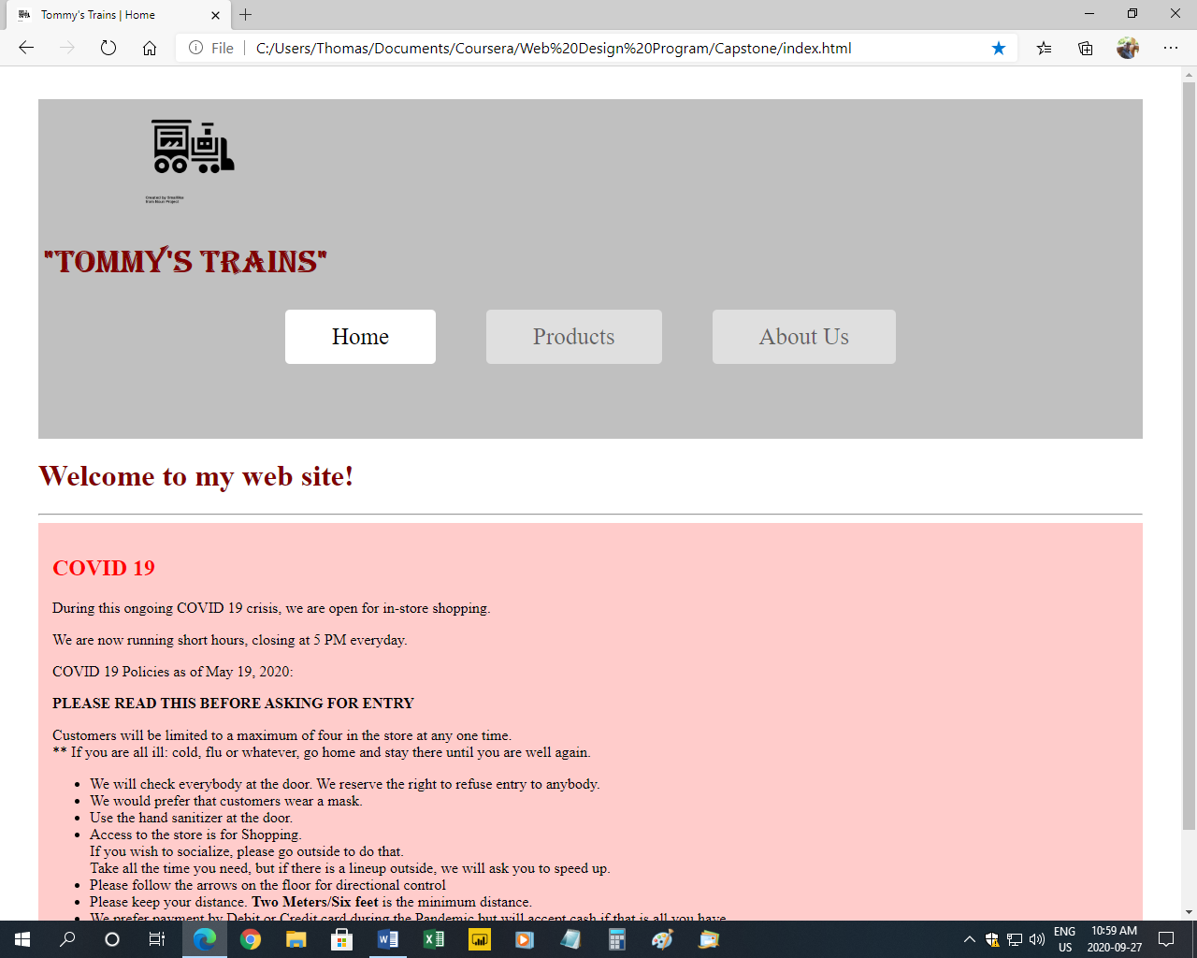

“Products” page

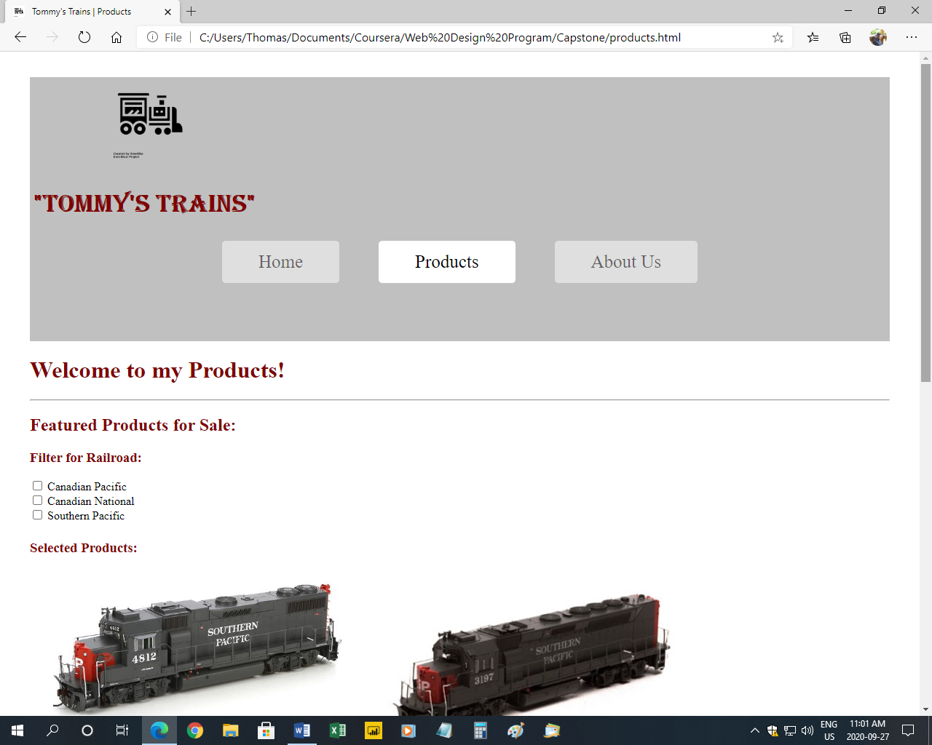

“About Us” page

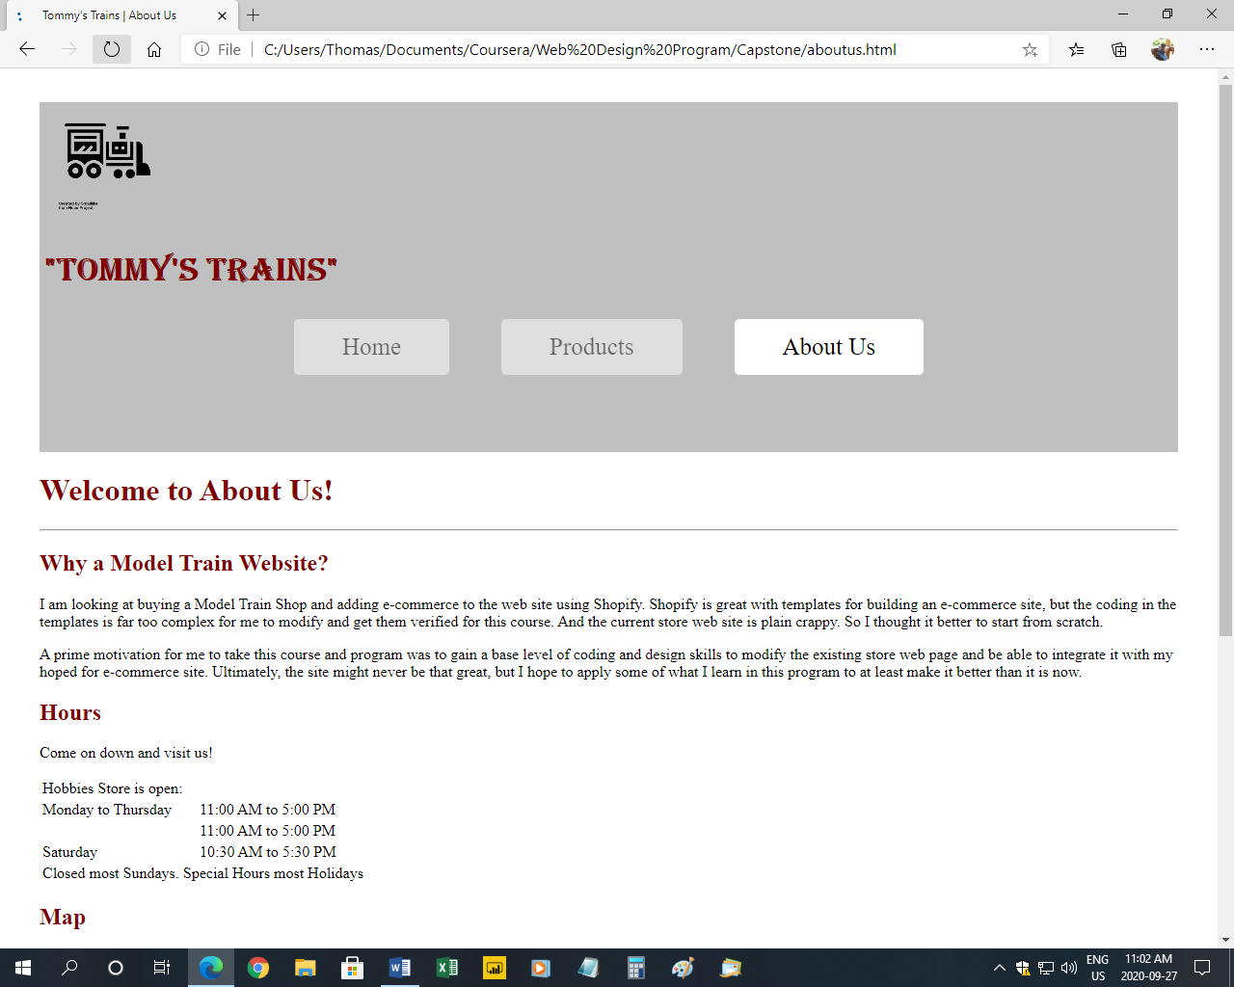

**Validation**

All 3 pages successfully validated at the site <https://validator.w3.org/>. I used the file upload method. See the screen shots below.

Successful validation of the “Home” (index) page

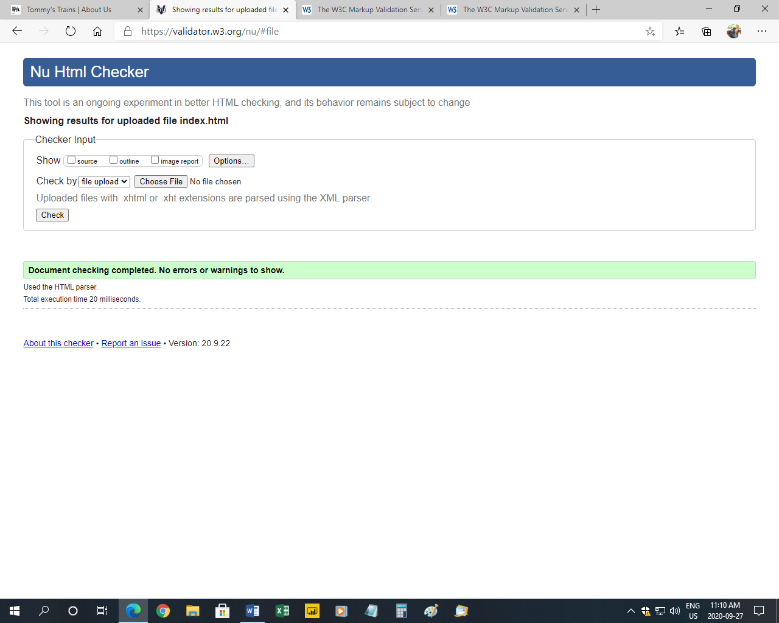

Successful validation of the “Products” page

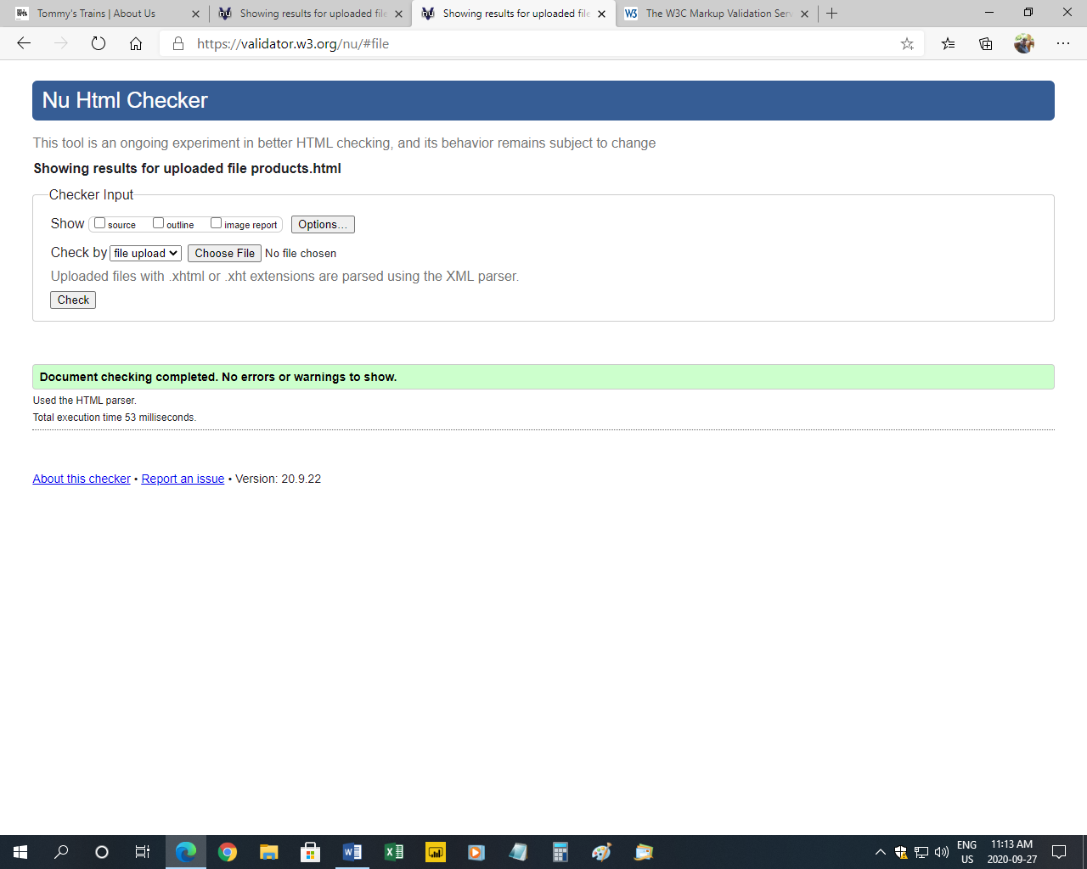

Successful validation of the “About US” page

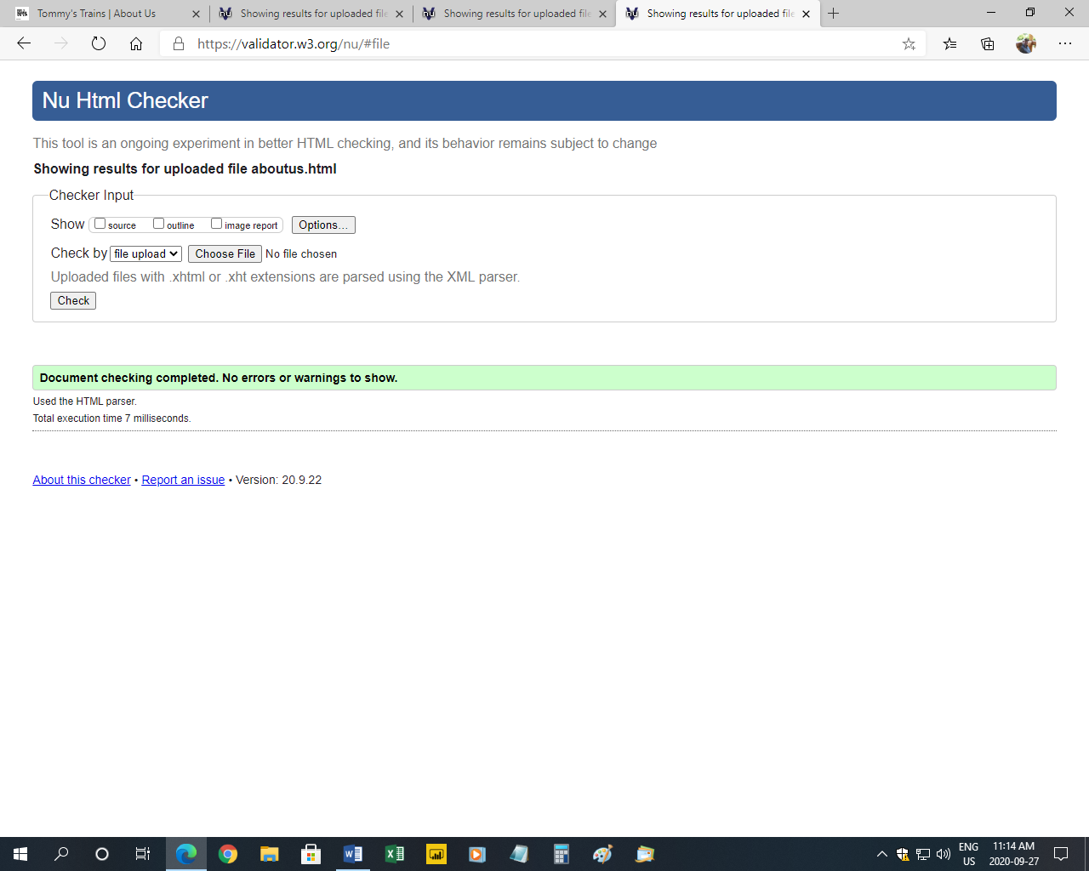

**Responsive Web Site**

I have 1 breakpoint set at 520 pixels. There are two main changes:

1. The navigation buttons appear stacked vertically and much of the padding is removed for the smaller screen.
2. The color of the horizontal line border changes. This was mostly to demonstrate the ability to do this coding.

CSS coding for the breakpoint:

/* For Responsive Design */

@media screen and (min-width: 520px) {

hr {

height: 0px;

background-color: #000000;

}

nav a {

margin: 0px 25px 80px 25px;

}

}

I took a mobile first approach to the site. All content that appears on the desktop is available on the mobile version. Elements are set with relative scaling (mostly percent as opposed to px). Images, navigation and other content that appears horizontally on the desktop, all appear stacked vertically on the mobile version.

The map feature on the “About Us” page is scaled at 95% with a max-width of 600. Thus, the map doesn’t look stupid large on the desktop, yet as the screen size shrinks below 600 px the map then shrinks in tandem with the shrinking screen size but makes use of the full width of the smaller platform.

At no time do any of the 3 pages require left-right scrolling, regardless of the screen size.

Mobile view of the “Products” page

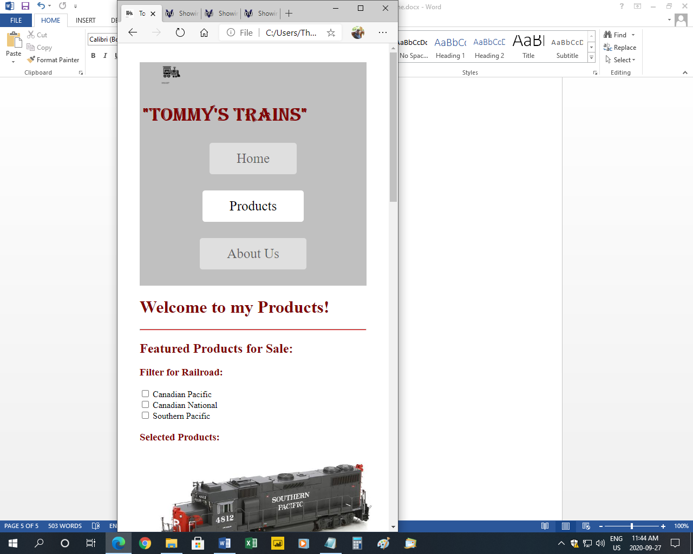

**Images**

There are 6 images on the “Products” page. These are of various model locomotives for “sale”. It took quite a while to figure out how to get them to present nicely side-by-side on the desktop while also stacking nicely in the mobile view.

There was also the issue of integrating the view with the added “Filter” feature (more about that later) so regardless of the number of products chosen or the size of the viewport the images appear nicely.

Mobile view of the “Products” page showing 3 images stacked

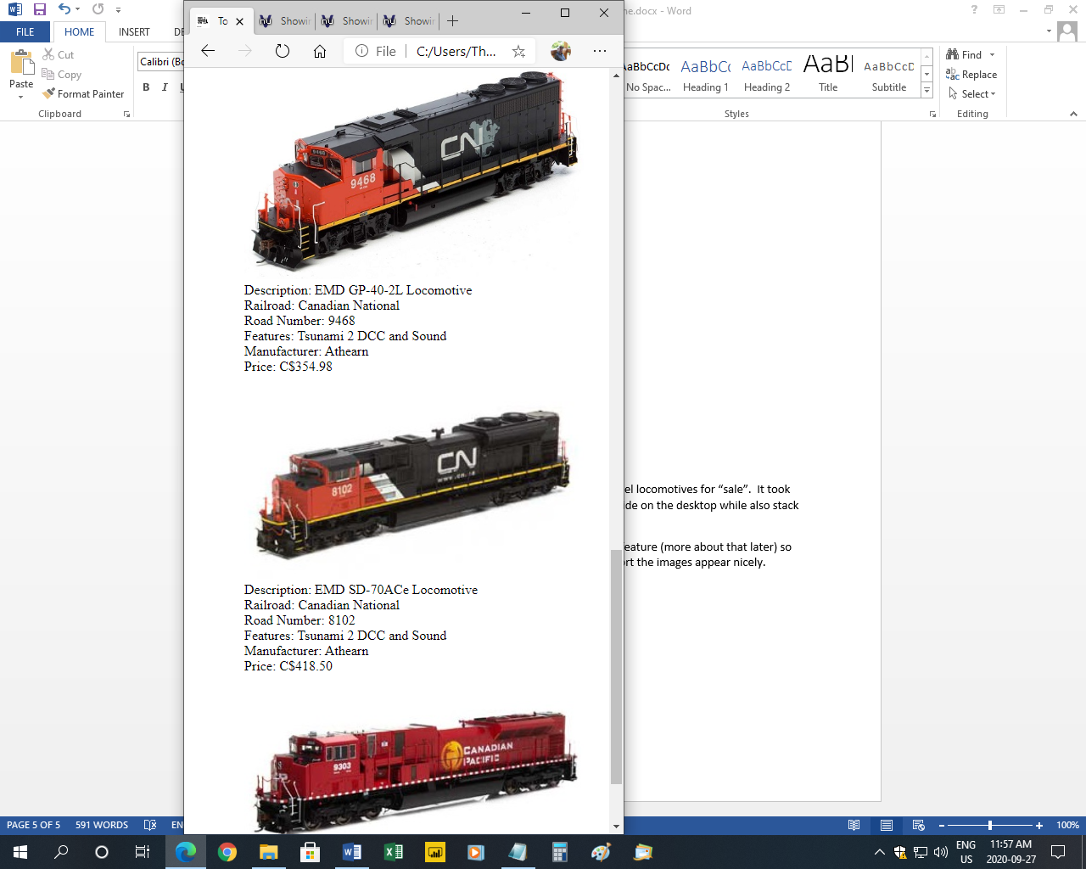

Desktop view of the “Products” page showing 6 images

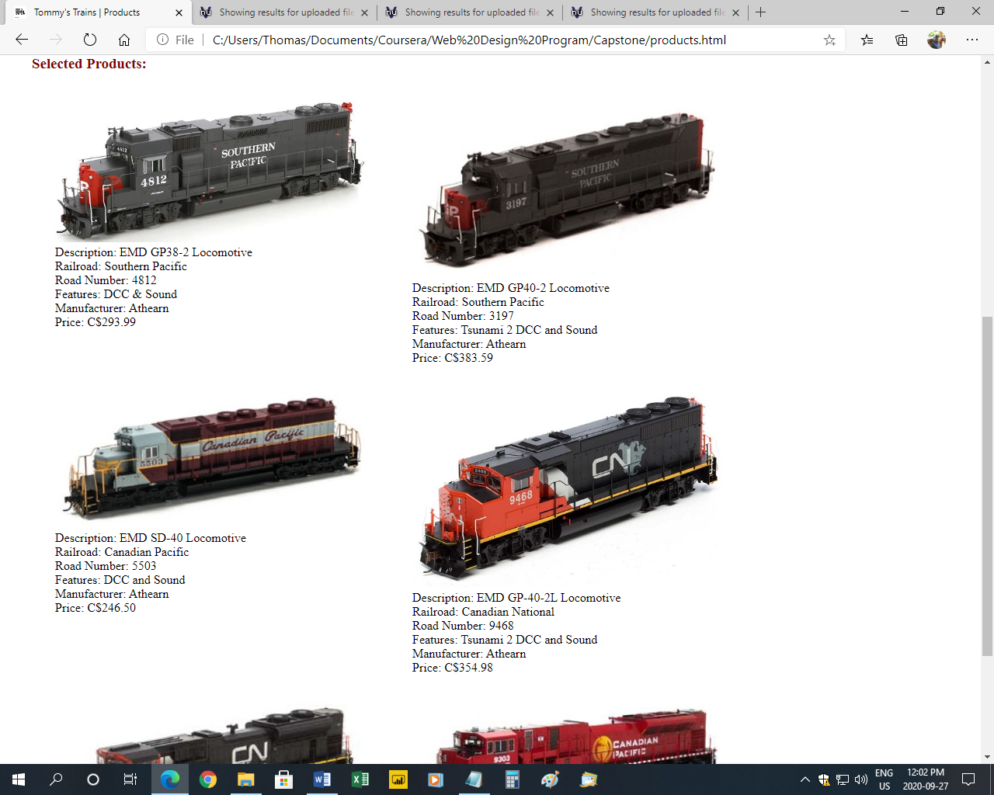

**Four Web Site Enhancements**

I have four web site enhancements.

1. Filter on the “Products” page. This is driven by an external JavaScript and the use of railroad classes in the HTML. This allows the user to select only those products that they want to see based on the railroad.

Initially, all 6 locomotives images and details appear. Then as the user selects 1 of the checkboxes, only the 2 images and details for that selected railroad appear. If a second selection is made, then 2 additional images and details appear related to that railroad. Checking the third checkbox causes the remaining 2 images and details appear (replicating the initial view).

Unchecking a checkbox, hides those related 2 images and details.

Any mix of the 3 groups of 2 images and details can appear, depending on the user’s selections.

If the user unchecks all 3 checkboxes, then no images and details appear on the screen.

Products Filter with only “Canadian Pacific” selected

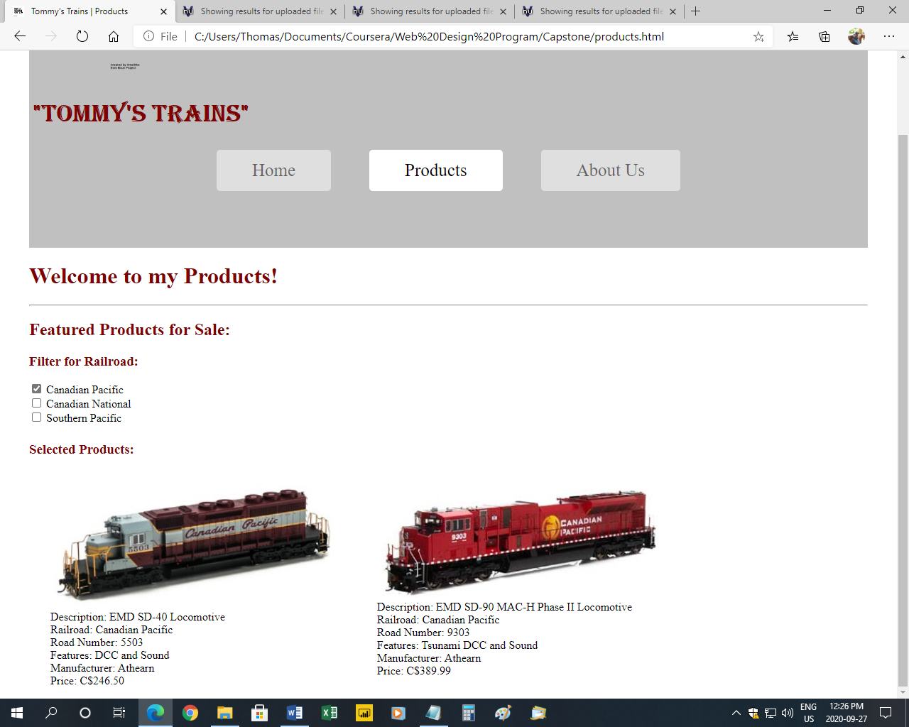

Products Filter with only “Canadian Pacific” and “Canadian National” selected

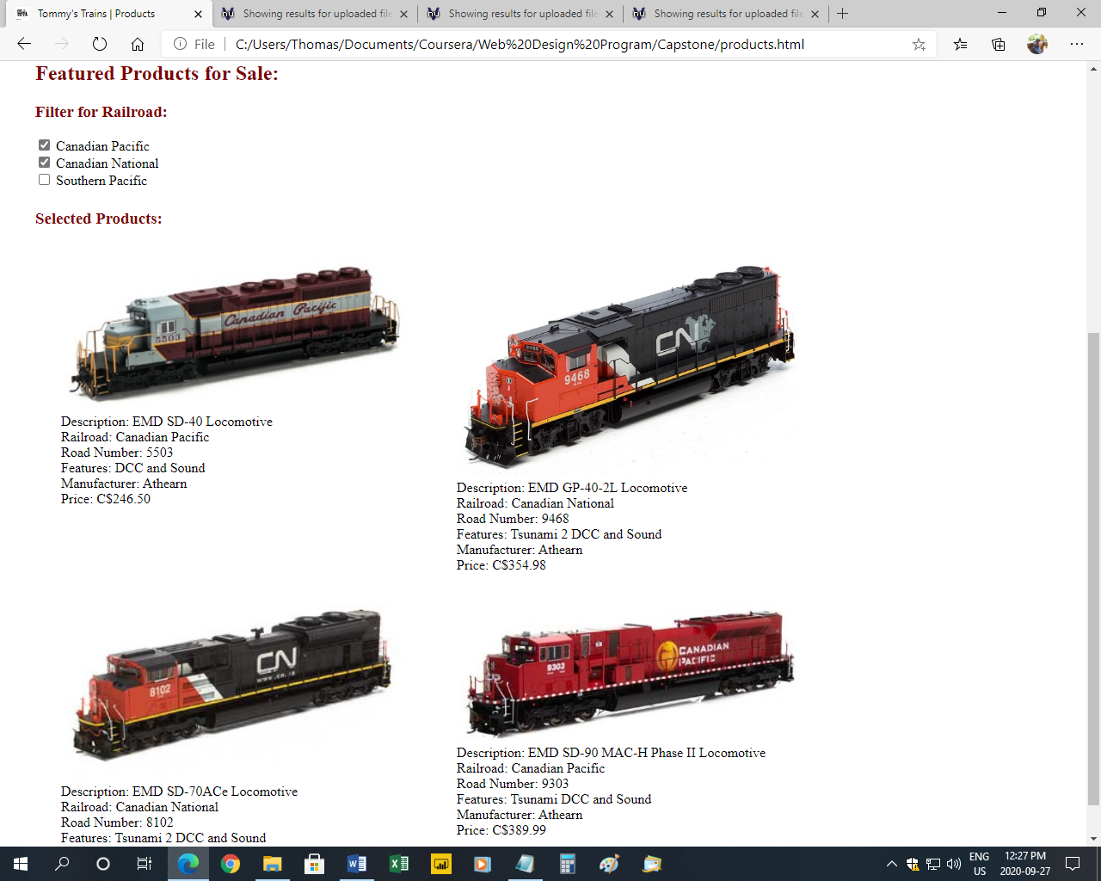

1. Interactive Google Map with store location indicated (not real location) appearing on the “About Us” page. The user can interact with the map by zooming in/out or moving the map with the cursor.

The attributes of the map are controlled in the external CSS stylesheet. If the attributes had remained in the imbedded code in the HTML, this would have created an error in the validation.

CSS code for styling the map plugin:

iframe {

frameborder: 0px;

border: 0px;

height: 450px;

width: 95%;

max-width: 600px;

}

Interactive Google Map appearing on the “About US” page

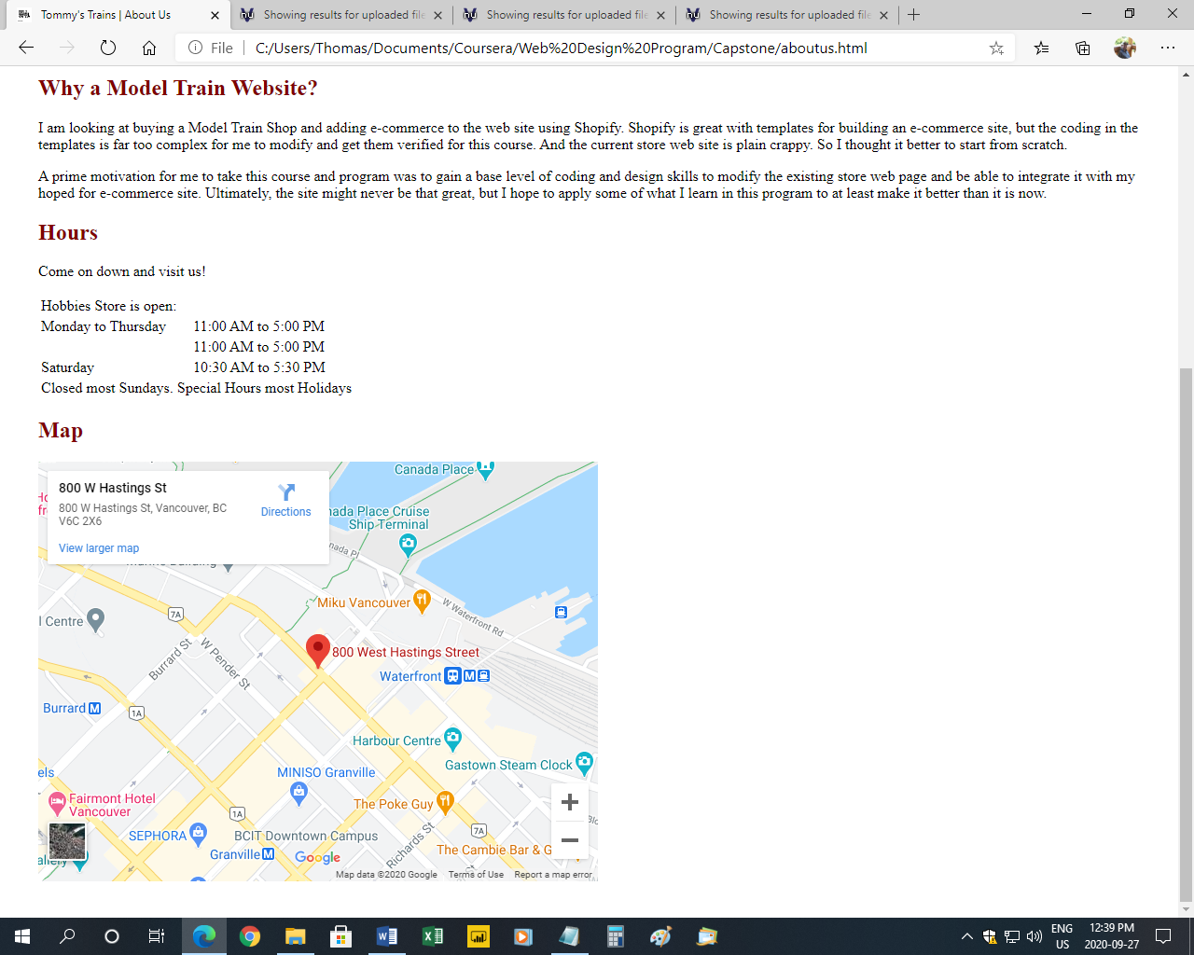

1. A Favicon was added to the site. This is the small icon appearing on the browser tab and in the saved favorites. In this case, it is a small 16x16 image. You probably can’t see the detail, because it is so small, but it is a mini version of the Tommy’s Trains “store logo” steam train icon appearing on the top left of each page (the full size icon was downloaded from the Noun Project site <https://thenounproject.com/>).

I used Microsoft Paint to shrink the image to the right size.

The code is placed in the <head> section of the HTML

<!-- Favicon -->

<link rel="shortcut icon" href="images/trainfavicon.png">

“Home” page showing Favicon (circled in red)

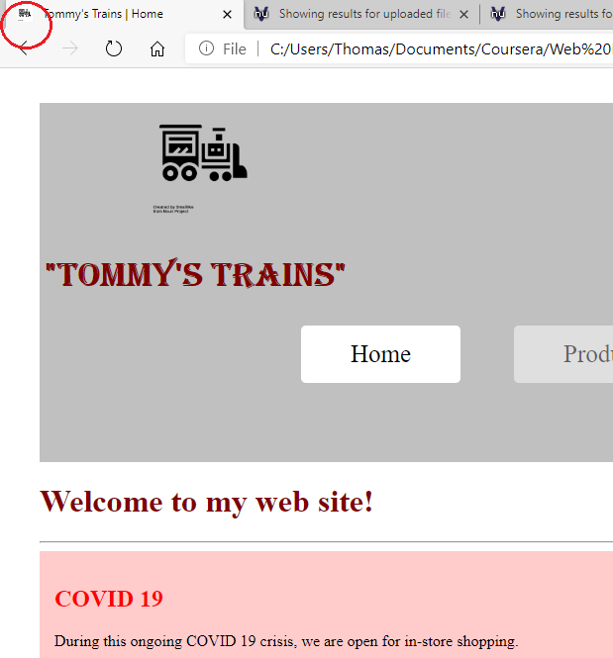

1. The fourth extra enhancement is the use of CSS transition: transform to animate the Tommy’s Trains logo. Upon load, the steam train logo moves across the page to the right.

Okay this is really dorky, but I find this really cool. And it looks great in the mobile view too.

In the HTML I set the image to class = "trainlogo":

<img src="images/trainicon.png" class="trainlogo" alt="train logo">

In the external CSS stylesheet I then set up the transform over a 2 second transition:

.trainlogo {

width: 10%;

transform: translate(90%, 0px);

transition: transform 2s;

}

Okay, it’s hard to demonstrate animation with still screen shots, but see how the logo has moved between the initial and final positions:

Initial position of transition Final position of transition

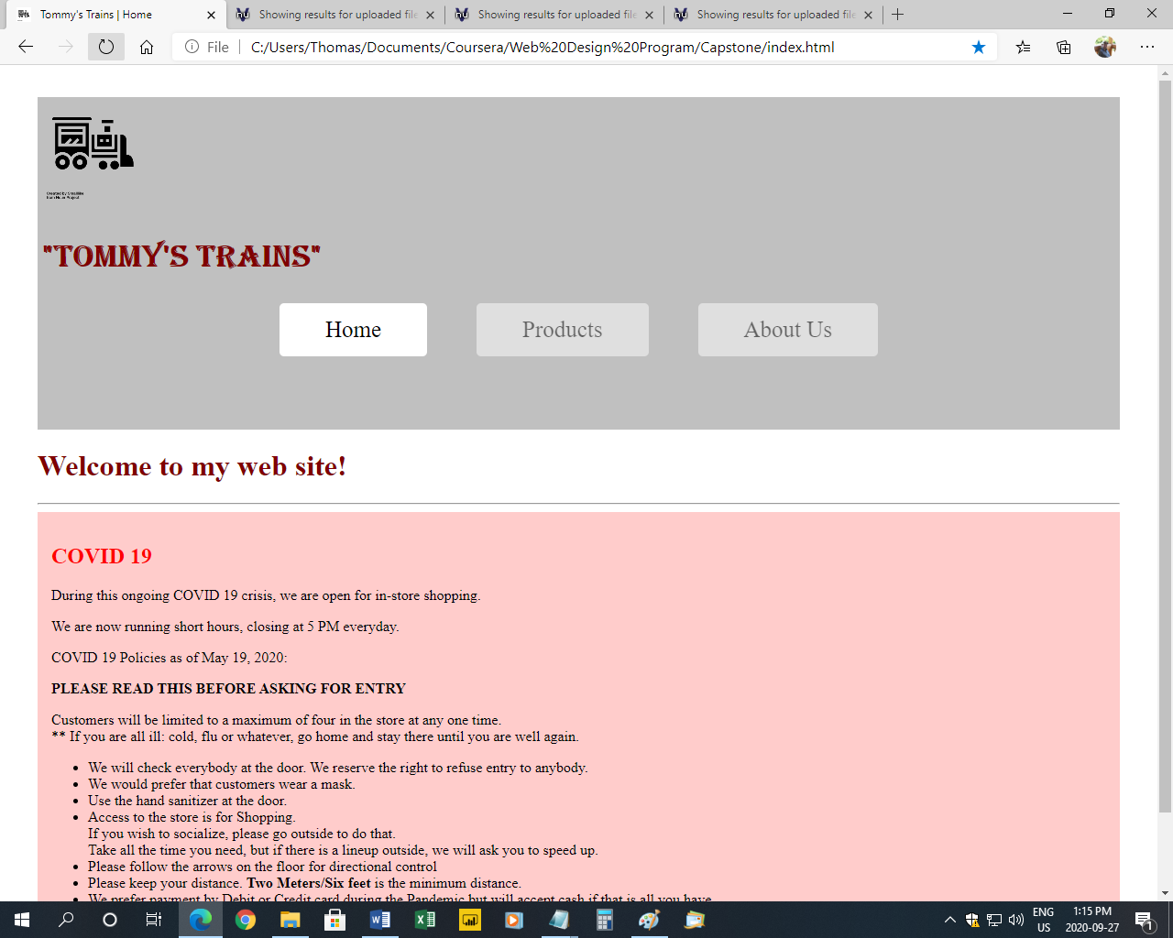 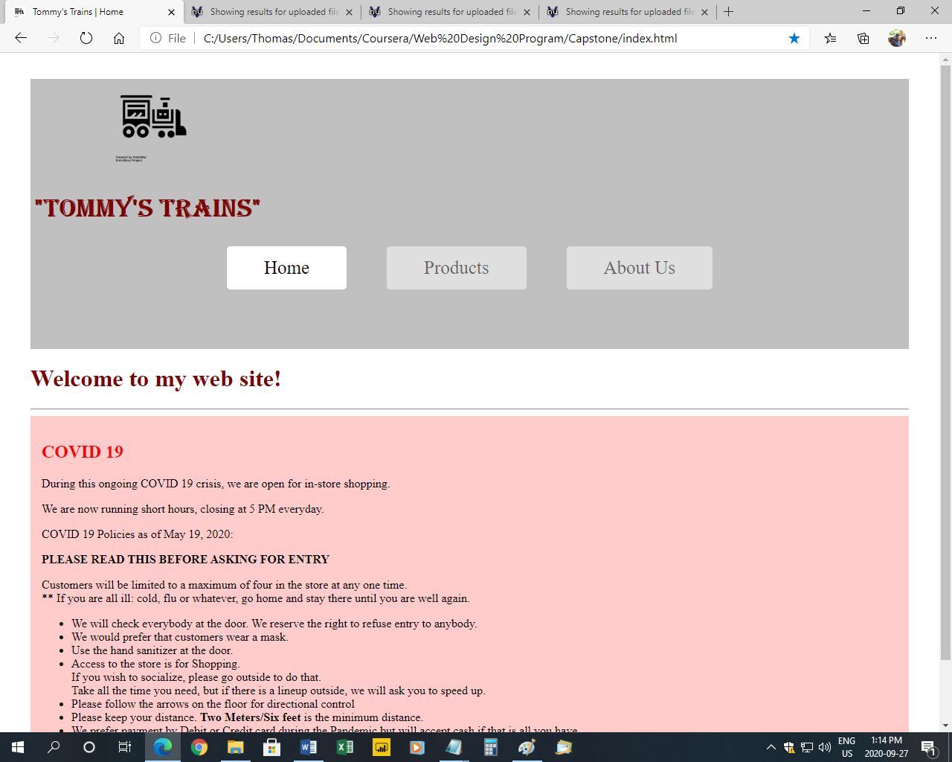

Thank you for reviewing my capstone project. Good luck with your future web projects!

Best wishes,

Tom